**Students’ guide to the Net Languages platform**

Essential courses

1. How to enter the course 2

2. The home page 3

3. Getting started 4

4. Support documents and other course information 5

5. Tools and resources 6

Text to speech 7

Record yourself tool 7

Dictionary 7

Grammar reference 8

Business centre 8

Translate into any language 8

Pronunciation tool 9

Interactive English 10

Fun and games 10

Forums 11

Audio speed control 12

Additional resources 12

# 1. How to enter the course

=Type your codes into the **Username** and **Password** sections and click on **Login**.

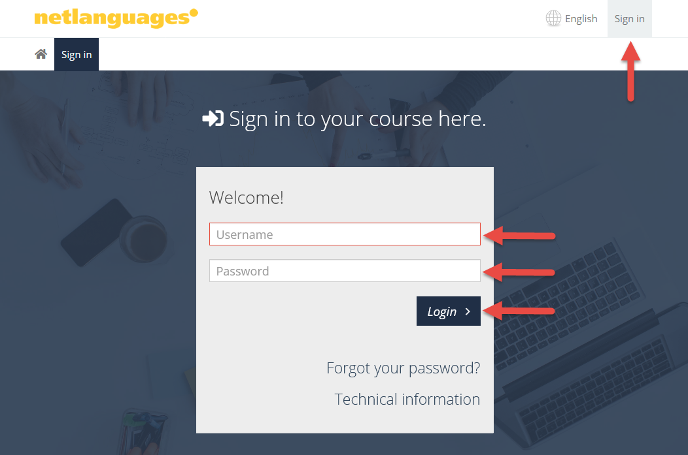

# 2. The home page

=Once you have logged in to the platform, you will see the **Home** page of the course. On the home page you can see the components of your course.

**Medical English for Health Professionals**

|  |  |
| --- | --- |
|  |  |

You can also see information about your progress and test scores.

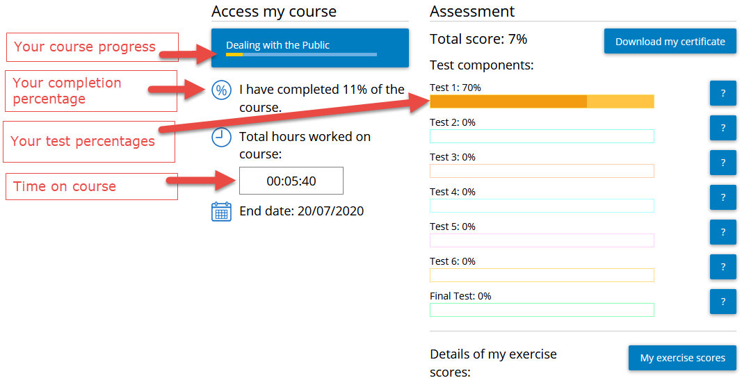

# 3. Getting started

=Select the first section of the course.

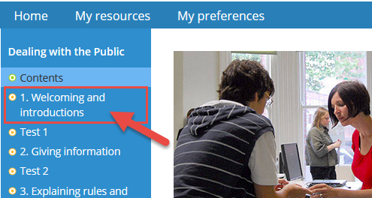

=Use the menu on the left to go to the different parts in the unit or section.

=Use the numbered tabs to go from one exercise to the next.

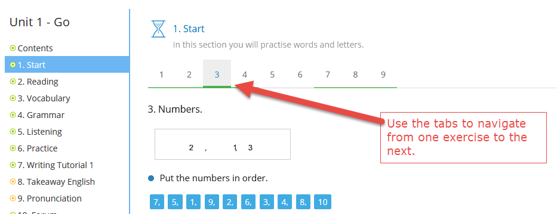

=Click on **Home** to choose the next unit or section. Click on **Logout** when you finish your session.

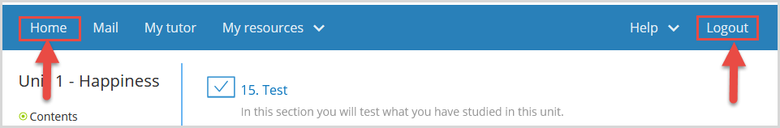

# 4. Support documents and other course information

=If you have support documents, you will see a section called **My documents**.

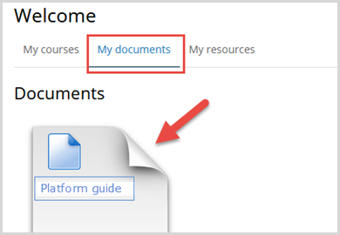

# 

# 5. Tools and resources

=To see the resources available in your course, click on **My resources**.

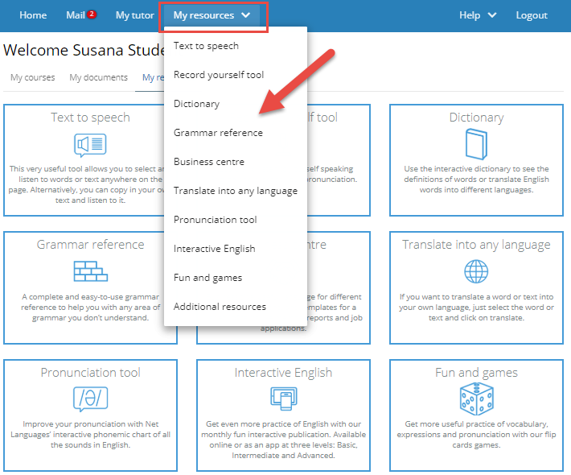

## Text to speech

|  |  |
| --- | --- |
|  |  |

## Record yourself tool

|  |  |
| --- | --- |
|  |  |

## Dictionary

|  |  |
| --- | --- |
|  |  |

## Grammar reference

|  |  |
| --- | --- |
|  |  |

## Business centre

|  |  |
| --- | --- |
|  |  |

## Translate into any language

=You can select any text on a page, listen to it spoken, and translate it into any language.

|  |  |
| --- | --- |
|  |  |

## Pronunciation tool

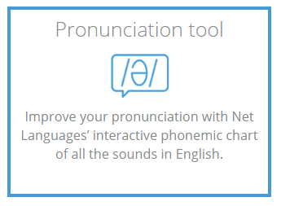

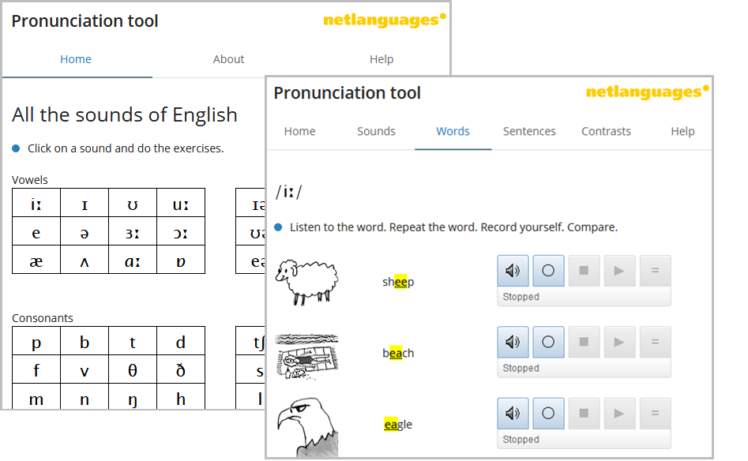

Interactive English

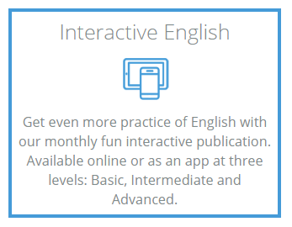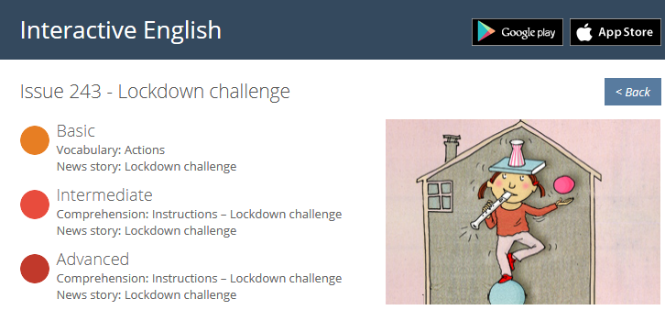

Fun and games

|  |  |
| --- | --- |
|  |  |

Forums

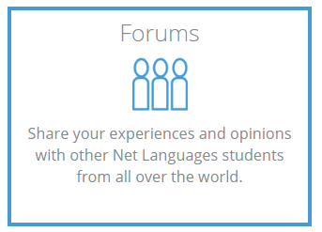

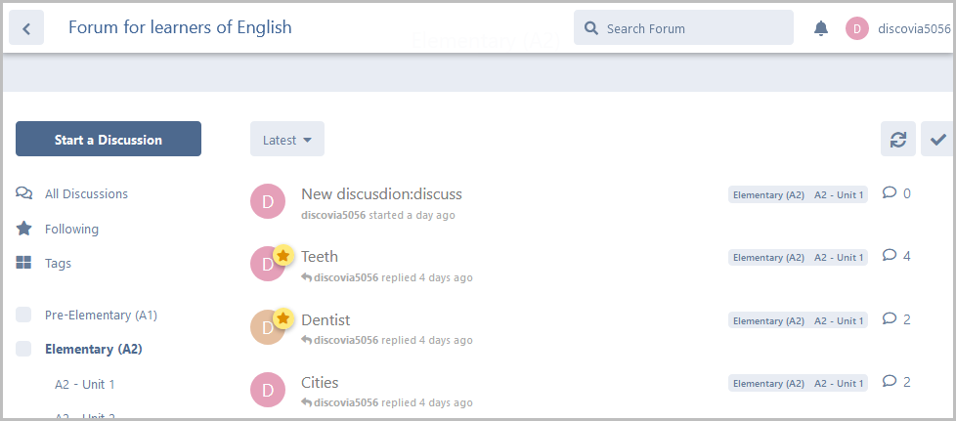

Audio speed control

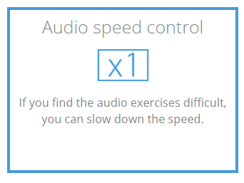 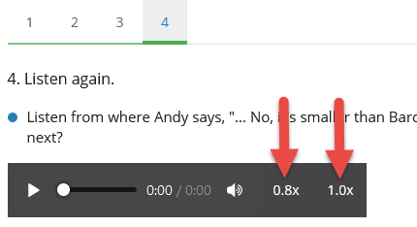

Additional resources

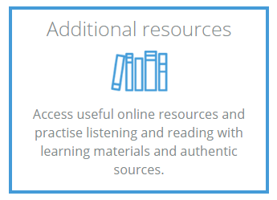

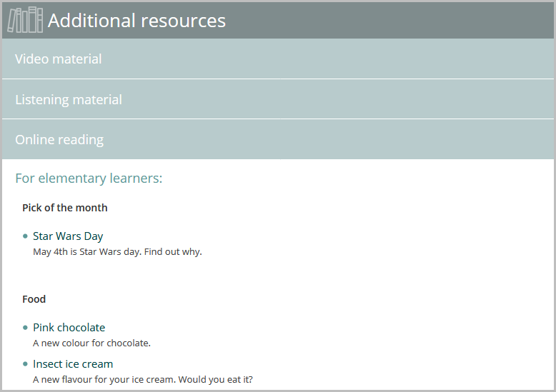

Each unit also contains speech recognition exercises. These are often in the PRONUNCIATION and TAKEAWAY ENGLISH sections of the unit. There are different types of exercises. They practise sounds, words, sentences and your fluency when you read aloud.

Each unit also contains speech recognition exercises. These are often in the PRONUNCIATION and TAKEAWAY ENGLISH sections of the unit. There are different types of exercises. They practise sounds, words, sentences and your fluency when you read aloud.